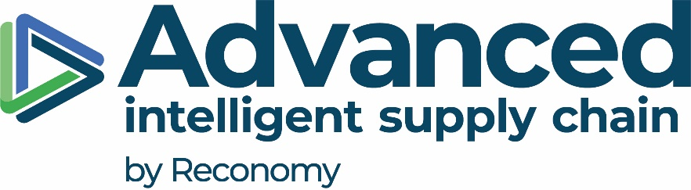

INTRODUCTION

At Advanced Supply Chain, we pride ourselves in creating a positive and values-based culture where all our people feel fairly treated, engaged, and appreciated. We are committed to taking more positive steps towards encouraging diversity in our workforce.

We believe our people make the difference. Our success has been, and will continue to be, made possible by the contribution our colleagues make every day. This report forms part of the framework used by Advanced Supply Chain to track its progress in one context of this important plan – specifically gender pay – and includes Advanced Supply Chain Group’s statutory release of its 2020 Gender Pay Gap. It also shares information about the strategic work we are undertaking to achieve pay equality and develop the inclusiveness and diversity of our business.

For clarity all companies with 250 or more colleagues are required to publish their gender pay gap under The Equality Act 2010 (Gender Pay Gap Information) Regulations 2017 (the “Regulator”). Employers are required to publish the gap in pay between their male and female colleagues and show the results in the form of the median basis (hourly pay based on the ‘middle’ person) and the mean basis (average hourly pay). Employers also need to show the distribution of gender in pay quartiles by splitting the workforce into four groups based on their average hourly pay rate and to show the percentage of male and female workers in the groups. Additional all Employers are required to disclose the percentages of workers earning bonus payment and split this by gender showing the gender pay gap on the business.

OUR COLLEAGUES

Advanced Supply Chain trades under 6 business entities:

- Advanced Supply Chain Group Limited
- Advanced Forwarding Limited
- Advanced Supply Chain (BFD) Limited
- Advanced Supply Chain (Logistics) Limited
- Advanced Supply Chain (HF) Limited
- Advanced Supply Chain (COR) Limited

For the purposes of this report, we are showing our combined results for the whole of the Advanced Supply Chain Group Family.

48 % Female Colleagues Overall
Although our overall colleague demographic has altered from the previous year’s results we continue to show diversity within our colleague profile.

52 % Male Colleagues Overall

GENDER PAY AND BONUS GAP
These results are reflective of the intake in our operative roles which has seen an overall increase in the number of male colleagues with the business.
Hourly Pay Gap
11%
Median
Mean
9%
For the eligible proportion of colleagues who received a bonus, our report shows a noticeable decrease in the gap between our male and female colleagues across the mean portion. The data also shows an increase across the median results mainly driven by contractual bonus payments which is payable at one point in the year.
Median
53%
Bonus Pay Gap
Mean
22%

PROPORTION OF COLLEAGUES RECEIVING A BONUS
During the reference period the number of colleagues receiving a bonus increased significantly compared to the previous period. Although there is a gap between male and female this shows a positive result with business is rewarding colleagues across the genders.
52% of the overall female population received bonus
31% of the overall male population received bonus

PAY QUARTILES

The above charts show the gender split across the Advanced Supply Chain Group. In the Upper Quartile we are demonstrating a shift towards more female colleagues who sit in the most senior roles – this is a fact that we are proud of however we are committed to ensuring the best people are appointed regardless of their sex. The Upper Middle Quartile shows an almost even split at this snapshot date which reflects the internal progression expectation predicted in the previous year’s results. The Lower Middle and Lower Quartiles have only had very small movements overall due to the volume of Operative level intake across the business.

OUR COMMITMENT
We continue to commit to drive forward our people agenda with inclusion and diversity at its heart, across our businesses. We continue to strive to further the improvement of gender split ratios across our roles by focussing on:-
- Succession and talent planning strategies
- Promoting the businesses across the industry – this will include specific recruitment strategies and growing the Resourcing Team
- Continued improvement of the salary review process
Advanced Supply Chain is committed to its People and ensuring equal pay principles are being driven across our businesses.
Our calculations follow the legislative requirements as set out in the Equality Act.
I confirm that the data published in this report is accurate for the snapshot date of 5th April 2020.

Claire Webb
Managing Director

